ChauffHer
Driven by women, for women
It in business lab
2024
ChauffHer
Driven by women, for women
1. Executive Framework
Introduction
In contemporary urban centers, millions of consumers depend on the continuous evolution of ride-hailing networks for daily mobility. However, access to mainstream transportation platforms introduces critical safety vulnerabilities for female passengers, as evidenced by a rising volume of high-profile security incidents that underscore the acute demand for safer alternatives.
ChauffHer directly addresses this critical market deficiency through a dedicated ridesharing application engineered exclusively for female passengers, prioritizing safety, institutional trust, and systemic women's empowerment. By operating a strictly female-to-female ecosystem—where both drivers and riders are verified women—ChauffHer instills the necessary confidence for secure transit while creating viable, autonomous economic opportunities for female drivers and entrepreneurs. Moving beyond mere geographic mobility, this platform seeks to redefine personal security and financial independence within the modern ridesharing industry.
Vision
To revolutionize urban mobility and establish global corporate leadership in specialized, women-only transportation networks, initiating a market era characterized by absolute safety, operational trust, and systematic gender empowerment. We achieve this through sustainable growth, strategic diversification into untapped regional markets, and an organizational culture where stakeholders, employees, and independent contractors are fundamentally valued and protected.
Mission
To engineer a secure, highly dependable, and inclusive transit platform tailored specifically to the unique needs of women. ChauffHer is committed to facilitating sustainable economic livelihoods for female drivers while guaranteeing peace of mind, premium convenience, and uncompromised safety for every rider. This mission is actively executed through rigorous corporate training programs, continuous technological innovation, and strategic partnerships dedicated to expanding safe public access.

2. Service Portfolio and Transit Tiers
Strategic Service Pillars
ChauffHer is engineered for optimal user experience and operational efficiency, leveraging an intuitive software infrastructure comparable to leading dynamic-fare applications such as InDrive or Yango.
- Dynamic Fare Flexibility: The platform empowers passengers by allowing them to propose a baseline fare for their specified destination. Independent drivers retain full autonomy to accept, reject, or counter these proposals based on real-time transit variables, fuel costs, and personal preferences, establishing a highly transparent market equilibrium.
- Diverse Fleet Options: To accommodate varying consumer budgets and urban travel requirements, ChauffHer integrates a broad multi-tier vehicle spectrum. The fleet ranges from highly economical short-distance options to premium corporate transport and green carpooling alternatives.
- Uncompromised Safety Protocols: Every operational layer is built to maximize protection for female users. This is achieved through enhanced software encryption, advanced real-time telematics, and a multi-stage background vetting protocol for all contractors.
Transit Fleet Categories
Fleet Tier | Target Use Case | Operational Attributes
Motorbike | Rapid urban transit & traffic mitigation | High agility, time-efficiency, and low cost; optimized for solo commuters bypassing heavy peak-hour congestion.
Auto Rickshaw | Short-distance regional transit | Highly economical and practical for navigating dense commercial zones, local bazaars, and narrow urban pathways.
Mini Ride | Budget-conscious urban travel | Fleet of clean, fuel-efficient compact hatchbacks tailored for individuals or small groups seeking low-cost, hassle-free city transit.
Standard Ride | Everyday professional commutes | Well-maintained, fully climate-controlled sedans optimizing passenger comfort, reliability, and smooth transit.
Premium Ride | Executive transit & executive events | Luxury vehicles offering enhanced cabin space, superior amenities, and executive service standards for corporate travel or specialized occasions.

3. Core Technical and System Features
User-Facing Features
- Exclusively Female Driver Network: All corporate fleet drivers are verified females, immediately establishing an environment of mutual trust and psychological comfort.
- Real-Time Telematics & Tracking: Continuous GPS monitoring is fully integrated into the interface, allowing passengers to seamlessly share live trip trajectories with emergency contacts or family members.
- Instantaneous SOS Mechanism: One-touch access within the app user interface that instantly routes distress alerts, vehicle data, and live coordinates directly to local law enforcement and the ChauffHer emergency response desk.
Driver-Facing Features
- Professional Onboarding and Training: Mandatory corporate training modules covering road safety, hygiene etiquette, conflict resolution, and elite customer relations to guarantee premium service delivery.
- Complete Schedule Autonomy: Drivers operate within a flexible independent contractor framework, granting them total authority over their operational hours and regional driving preferences.
- Transparent Financial Analytics: An intuitive digital dashboard providing real-time, comprehensive breakdowns of daily, weekly, and cumulative earnings, including instant tracking of incentives, bonuses, and rider tips.
- Driver Security Arrays: Specialized driver-side distress indicators alongside automated fleet tracking to protect contractors against external liabilities.
Structural Safety Measures
- Multi-Tier Profile Verification: A rigorous background screening process mandated for both drivers and riders, requiring biometric identification or government-issued credentials to ensure absolute network integrity.
- Automated Ride Monitoring: System-level machine learning algorithms evaluate active trips in real time, automatically flagging anomalous route deviations, unexpected prolonged stops, or atypical delays.
- Automated Family Check-In System: Automated push notifications dispatched to a rider's designated emergency contacts immediately at the initiation and conclusion of every trip.
- Gender-Specific Corporate Support: A dedicated, fully specialized female support desk operating 24/7 to resolve customer queries and operational incident reports with maximum empathy and professional care.

4. Market Overview & Strategic Analysis
Industry Landscape
The ride-hailing sector in Pakistan has experienced exponential growth due to rapid urbanization and escalating demands for time-efficient, accessible transit. Traditional private chauffeurs and legacy taxi services have largely been replaced by scalable, fully digitized mobile applications like Uber and Careem. As the market matures, niche service providers and regional players are emerging to capture underserved market verticals.
ChauffHer targets a highly lucrative, historically underpenetrated market segment by focusing exclusively on female mobility. Given the heightened societal concerns regarding transit safety, the demand for targeted, gender-specific transportation networks is accelerating. The platform's initial deployment focuses on primary urban centers, specifically Lahore, Karachi, Islamabad, Peshawar, Faisalabad, and Quetta—each possessing high-density populations and distinct commuter demographics.
Key Industry Trends
- Escalating Safety Demands: Security remains the paramount variable dictating consumer choices among female commuters in Pakistan. High-profile safety breaches across mainstream apps have shifted consumer preferences toward trusted, specialized platforms that guarantee isolated security.
- The Rise of Gender-Specific Verticals: As corporate social responsibility and safety awareness mature, female commuters demonstrate an overwhelming preference for female drivers, signaling a major market shift toward segregated transit models.
- Environmental Sustainability: Heightened corporate and consumer awareness regarding eco-friendly practices has increased interest in green mobility options, opening strategic pathways for electric vehicle (EV) integration and structured corporate carpooling.
- Secondary Urbanization: Ride-hailing demand is expanding beyond traditional metropolitan hubs like Lahore and Karachi into tier-two cities and expanding suburban zones, driven by inadequate public infrastructure.
Growth Opportunities
- Unserved Regional Penetration: Extending ChauffHer's operational footprint into secondary cities and peri-urban zones that face a complete deficit of secure public transit options for women.
- International Scalability: Exporting the specialized all-female corporate model to developing international markets that present identical cultural frameworks and female safety constraints.
- Socio-Economic Empowerment: Facilitating micro-entrepreneurship by transforming untrained individuals into professional, financially independent drivers through corporate sponsorship and development tracks.
- Sustainable Fleet Innovation: Implementing localized carpooling modules and piloting electric vehicles to drastically optimize driver fuel margins while fulfilling corporate sustainability goals.
- Public-Sector Collaboration: Establishing strategic alliances with municipal governments and transport authorities to secure infrastructure subsidies, specialized regulatory licensing, and state-backed insurance programs.
- Advanced Technological Roadmap: Investing in proprietary technical modules, including an automated Multilingual Support Interface, an integrated Driver Training Portal, and a predictive "Preferred Driver Matching" machine learning algorithm.

5. Target Market Segmentation
[ChauffHer Market Segmentation]
|
+-----------------------+-------+-------+-----------------------+
| | | |
[Working Professionals] [Students] [Homemakers/Mothers] [Corporate Travelers]
Market Segmentation Matrix
1. Working Professionals (Ages 25–45)
- Core Needs: Highly reliable daily commuting, strict punctuality, seamless corporate expense tracking, and zero-latency booking.
- Key Characteristics: Professionally driven, highly time-conscious, and possessing strong purchasing power; seeks maximum predictability and minimal waiting periods.
- Primary Pain Points: Commute delays, safety concerns during late-evening corporate travel, and unpredictable surging prices on mainstream platforms.
2. Academic Students (Ages 18–24)
- Core Needs: Highly affordable, accessible, and digitally fluid transit to and from universities, college campuses, and entry-level workplaces.
- Key Characteristics: Highly tech-savvy, digitally interconnected, price-sensitive, and likely to travel in consistent peer groups or short-distance urban circuits.
- Primary Pain Points: Limited disposable income, vulnerability on standard public transportation, and lack of digital payment flexibility.
3. Mothers & Homemakers (Ages 30–50)
- Core Needs: Secure, multi-stop mid-day transit optimized for household management, retail errands, and childcare transportation (school pickups/drop-offs).
- Key Characteristics: Family-oriented, highly safety-conscious, and heavily reliant on vehicular comfort, cleanliness, and courteous driver conduct.
- Primary Pain Points: Navigating crowded commercial markets alone, anxiety surrounding child safety during travel, and off-peak app availability.
4. Corporate Executives & Travelers (Ages 25–50)
- Core Needs: Premium, elite transport solutions for inter-city travel, airport transfers, corporate summits, and high-profile business engagements.
- Key Characteristics: Quality-driven, highly discerning, expects flawless corporate etiquette, punctuality, and executive-tier amenities.
- Primary Pain Points: Substandard vehicle maintenance in general fleets and an absence of specialized premium executive protocols for women.
Market Targeting Strategies
- Professional Vertical: Targeted business-to-business (B2B) corporate outreach, institutional partnerships for corporate employee transport packages, and professional networking campaigns executed on platforms like LinkedIn.
- Academic Vertical: Campus-level brand ambassador networks, localized student discount structures, and heavy engagement through interactive social media marketing campaigns (e.g., Instagram).
- Community Vertical: Hyper-local outreach via family networks, parenting circles, and lifestyle blogs, utilizing localized promotional incentives tailored around domestic and school schedules.
- Executive Vertical: Premium corporate account structures, corporate frequent-flyer reward alignments, and specialized executive fleet options guaranteeing elite-tier service parameters.
6. Strategic Business Analyses
SWOT Analysis
Strengths
- Defensible Market Niche: A highly specialized, purpose-built platform positioning ChauffHer as an immediate market leader in specialized female transit.
- Socio-Economic Value Proposition: Strong social impact narrative that fosters economic inclusion, independent entrepreneurship, and financial self-sufficiency for female contractors.
- Advanced Algorithmic Utility: Incorporates unique technological advantages such as user-driven fare negotiations, advanced telematics, and personalized driver pre-selection profiles.
- Resonant Brand Equity: A powerful, emotionally resonant corporate identity that establishes high consumer retention through shared alignment on safety and empowerment.
Weaknesses
- Constrained Initial Footprint: Current operational presence is limited to select urban territories, temporarily capping aggregate market volume.
- Elevated Operational Expenditures: Intensive capital allocation requirements for multi-stage driver screening, onboarding, security infrastructure, and continuous tracking maintenance.
- Localized Cultural Friction: Potential resistance within highly conservative regional pockets where public female employment or autonomous tech-driven mobility faces legacy social friction.
- Early-Stage Brand Equity: Building institutional trust as an early-stage venture against entrenched multinational competitors requires aggressive, sustained marketing investments.
Opportunities
- State and Policy Alignments: Alliances with governmental bodies for clean energy subsidies, public security endorsements, and institutional validation.
- Labor Market Activation: Capitalizing on the rising numbers of women seeking independent, flexible income streams to continuously scale the driver supply chain.
- Green Fleet Integration: Introducing eco-friendly options (EV infrastructure and carpooling algorithms) to attract environmentally conscious demographics while optimizing overhead costs.
- Uncapped Geographic Expansion: Rapid first-mover replication of the business model across secondary domestic markets and matching international emerging economies.
Threats
- Aggressive Industrial Rivalry: Entrenched multinational ride-hailing conglomerates (Uber, Careem, InDrive) possess vast capital reserves and can implement aggressive pricing strategies or introduce matching gender filters.
- Dynamic Regulatory Changes: Volatile regulatory environments, shifting digital tax frameworks, and evolving labor compliance laws governing independent contractor ecosystems.
- Macroeconomic Headwinds: Systemic economic inflation, volatile fuel prices, and fluctuating currency valuations that directly squeeze profit margins and consumer spending power.

Porter’s Five Forces Analysis
1. Threat of New Entrants: Moderate
While the technological architecture required to launch a scalable ridesharing app demands significant upfront capital, technical expertise, and operational overhead, the specific market pull for specialized female safety creates a highly attractive niche. New localized players may attempt entry into isolated geographic regions; however, ChauffHer’s comprehensive vetting systems, early brand equity, and specialized onboarding create a strong competitive barrier.
2. Bargaining Power of Suppliers (Drivers): Moderate
The primary suppliers are independent female drivers. Because proficient, licensed female drivers represent a scarce labor asset in the region, their baseline bargaining power is naturally elevated. ChauffHer mitigates this supplier risk by providing industry-leading revenue splits, total schedule flexibility, comprehensive security nets, and advanced driver support networks to remain the platform of choice.
3. Bargaining Power of Buyers (Riders): High
Consumers within the urban ride-hailing sector possess low switching costs and an abundance of alternatives, including traditional taxis, public transit, and major digital competitors. Buyers display high price sensitivity and fluctuate between applications based on immediate fare costs, vehicle ETA, and security. ChauffHer addresses this by providing unique, non-commoditized security features and user-centric fare flexibility that generic competitors cannot easily match.
4. Threat of Substitutes: Moderate
Substitutes include traditional public buses, metro rail systems, legacy yellow taxis, and private carpooling. While these substitutes are often cheaper, they fundamentally fail to provide the core values of specialized safety, door-to-door convenience, and psychological comfort that define ChauffHer's value proposition.
5. Intensity of Competitive Rivalry: High
The broader ride-hailing industry in Pakistan is a fiercely contested space dominated by heavily capitalized global firms. Competitors continuously weaponize aggressive pricing, driver incentives, and deep marketing spend to capture market share. ChauffHer successfully neutralizes direct competitive pressure by completely bypassing the generalized mass-market price war, competing instead on an uncompromised, highly insulated safety matrix and a purpose-built corporate mission.

7. Sales and Marketing Strategy
- Omnichannel Digital Campaigns: Deploying high-conversion digital marketing initiatives across Instagram, Facebook, and LinkedIn. Campaigns will pivot away from generic advertising, focusing squarely on clear narratives of safety, corporate professionalism, and structural female empowerment. This includes strategic collaborations with prominent female thought leaders, corporate professionals, and social advocates to build brand validation.
- Strategic Referral & Retention Frameworks: Implementing an algorithmic peer-to-peer loyalty referral program. Current users are incentivized with ride credits and premium tier upgrades for onboarding new verified riders, utilizing organic word-of-mouth dynamics to reduce client acquisition costs while scaling the network.
- Corporate and B2B Community Engagement: Establishing institutional footprints by conducting safety seminars, professional mobility workshops, and corporate outreach programs within universities, corporate headquarters, and prominent non-governmental organizations (NGOs) to secure bulk employee and student transport accounts.
- Targeted Localized Activations: Executing offline marketing placements across high-density consumer touchpoints, including premium shopping malls, corporate business parks, and university campuses. These activations will align with regional cultural festivals and national events to maximize localized visibility.
- Feature-Centric Product Demonstrations: Publishing targeted product showcases, video tutorials, and live consumer case studies highlighting ChauffHer’s unique product features (e.g., the bidirectional fare-negotiation system, family telematics access, and the preferred driver algorithm) to visually illustrate how our technology ensures absolute consumer safety and trust.

Business Branding Materials


Logo

Business Cards


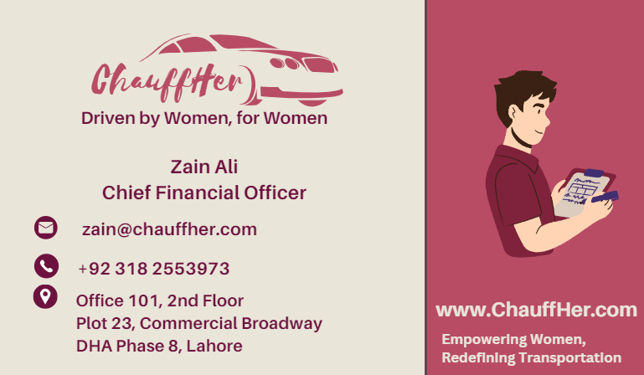
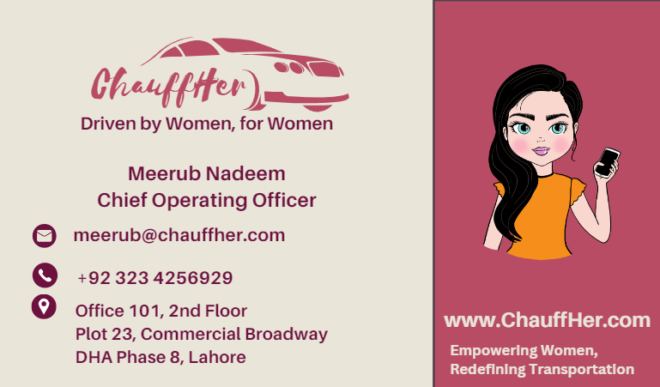
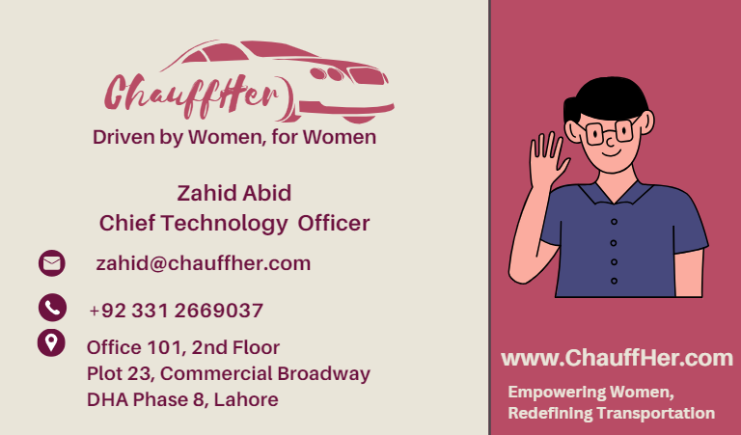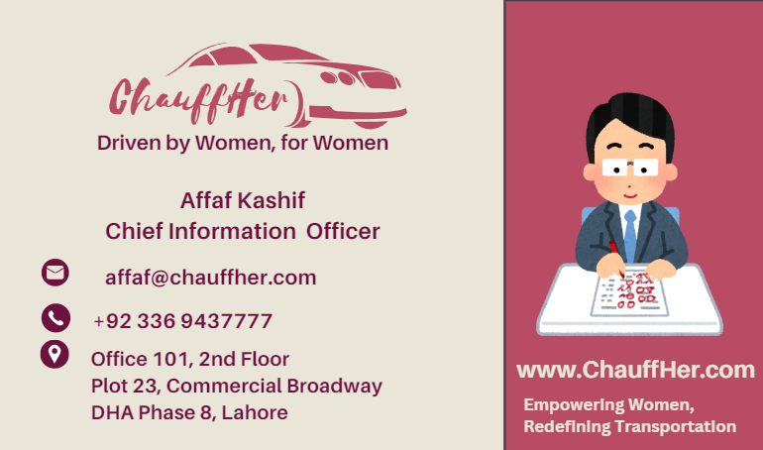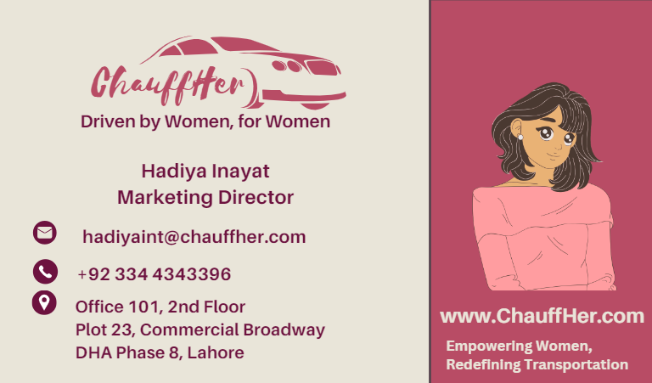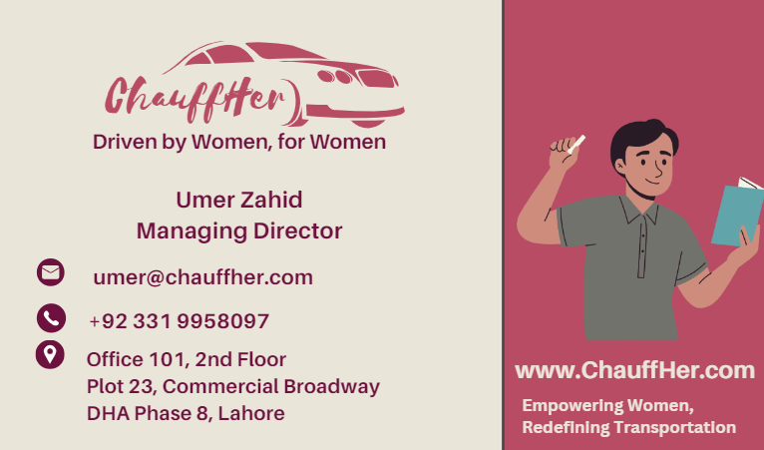

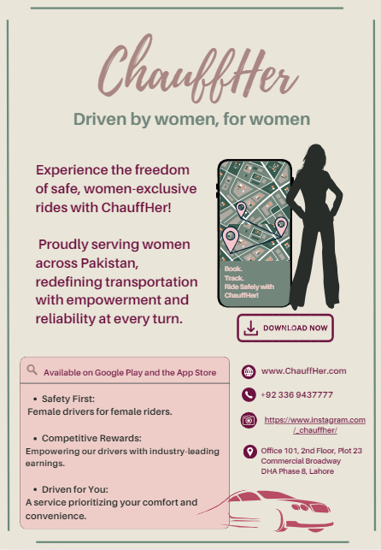
Flyer

Newsletter
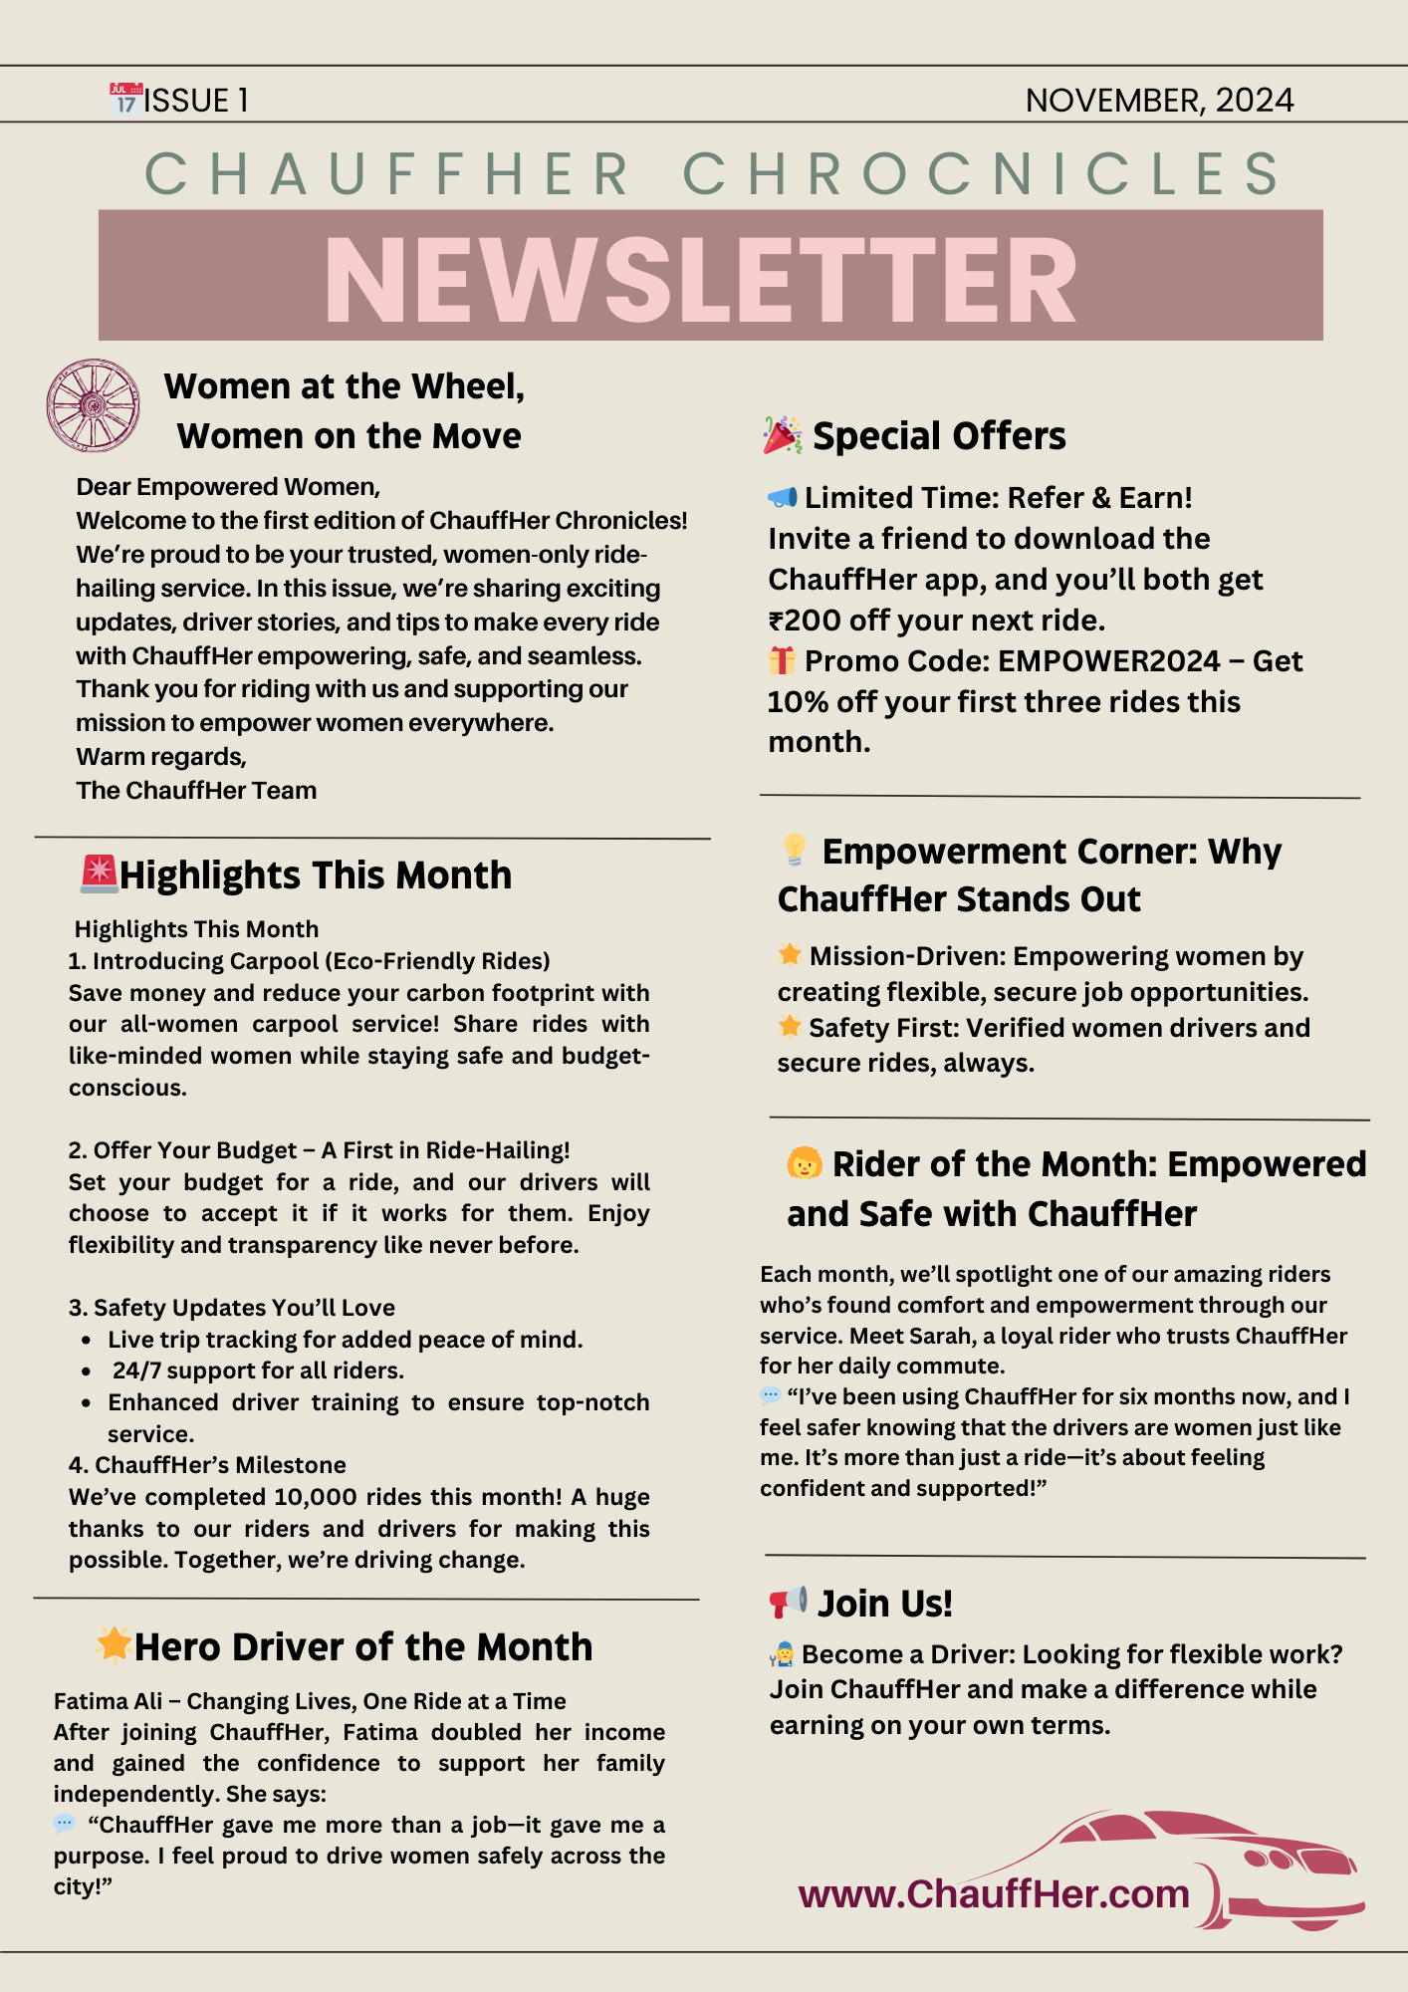

ALL LINKS:
Website: https://l245518.wixsite.com/chauffher

LinkedIn: https://www.linkedin.com/company/chauffherr/about/?viewAsMember=true

Instagram: https://www.instagram.com/_chauffher/

Facebook: https://www.facebook.com/profile.php?id=61569293715709&mibextid=LQQJ4d&rdid=QY8NN9yhLpard8gA&share_url=https%3A%2F%2Fwww.facebook.com%2Fshare%2F15XF8F7krv%2F%3Fmibextid%3DLQQJ4d

Meerub Nadeem 24L-5741
Zahid Abid 24L-5518
Zain Ali 24L-5618
Hadiya InayatUllah 24L-5559
Affaf Kashif 24L-5508
Umer Zahid 24L-5647
BFT - B
Disclaimer - (All Company positions are hypothetical)

